UNIT 3: DIGESTION AND RESPIRATION.
- Human nutrition.
Humans are unable to access nutrients directly. Nutrients, which are found in food, are complex mixtures of substances that our body has to transform in order to be able to use them. The nutrition process requires four closely related systems that work together to perform all the necessary functions; the digestive, respiratory, circulatory and excretory systems.
The nutrition process is divided into three stages:
- Obtaining both nutrients (Digestive system) and oxygen (Respiratory system).
- Distributing nutrients and oxygen, and collecting waste products and carbon dioxide (Circulatory system)
- Eliminating both waste products (Excretory system and sweat glands-skin) and carbon dioxide (Respiratory system).

- The human digestive system.
We need food to fuel our bodies for energy, growth and repair.
There are four basic stages in the digestive process: ingestion, digestion, absorption and egestion.
Ingestion: intake of food.
Digestion: mechanical and chemical break down of food.
Absorption: transfer of nutrients from the digestive tract into blood or lymph.
Egestion: elimination of substances that can’t be absorbed.
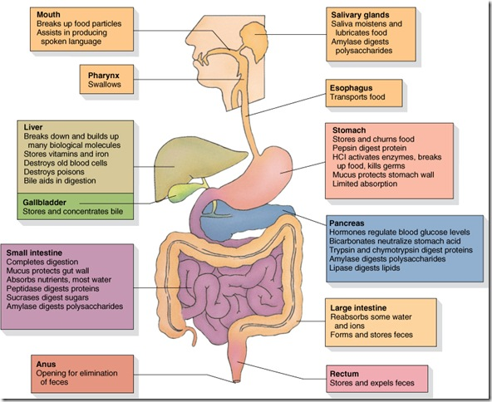
  - What makes up our digestive system?
The human digestive system includes the digestive tract and its accessory glands.
The digestive tract, also called the gastrointestinal tract, is a long twisting tube that starts at the mouth and ends at the anus and it has the following parts: the mouth (oral cavity), pharynx, oesophagus, stomach, small intestine and large intestine.
The accessory glands are complex organs that secrete substances into the digestive tract. These secretions contain substances involved in breaking down or digesting food. They are: The salivary glands, the liver and the pancreas.
  - Digestion.
Digestion is the process by which foods are transformed into simpler substances (nutrients), so they can be utilized by our cells. This process can be mechanical or chemical:
- Mechanical digestion: food is ground, cut up and mixed with digestive juices to form a paste.
- Chemical digestion: food is broken down by hydrolytic enzymes which extract nutrients from the food with the help of other substances such as acids and bile salts.
    - MOUTH
The actual process of digestion starts in the stomach; however, three other processes prepare the food inside the mouth: salivation, chewing and swallowing.
- Salivation or insalivation: food is mixed with saliva. Saliva is a watery liquid secreted by the salivary glands. It consists of water, mineral salts and proteins, such as salivary amylase (enzyme that starts the chemical digestion of starch); mucin (protein that gives saliva viscosity) and lysozyme (enzyme that attacks certain bacteria that enter the mouth).
- Chewing or mastication: this is a mechanical process carried out by the teeth and tongue, which move food into position. Food is crushed and ground into smaller chunks to facilitate its digestion.
- Swallowing or deglutition: this is the movement of the food bolus from the mouth towards the pharynx (throat), forcing the epiglottis to close the entrance to the larynx. The bolus passes into the oesophagus, and is moved downwards as the two muscles layers contract and relax (peristalsis). The oesophagus ends in the stomach.
    - STOMACH
Food going down the oesophagus enters the stomach when the cardiac sphincter relaxes. The entering of the bolus stimulates the production of gastric acid and the stomach starts to move (secretion of gastric juices is an involuntary act that begins as soon as we see food and as food enters our mouth). Gastric acid contains hydrochloric acid and pepsin:
- Hydrochloric acid activates pepsin enzymes and eliminates most of the microorganisms that it may contain.
- Pepsin is an enzyme that breaks the bonds between the amino acids in proteins, partially digesting those proteins.
The movements of the stomach mix food with gastric acid. This process produces a highly acidic paste called chyme. Once the gastric digestive process is finished, the pylorus opens and the chime moves into the small intestine.
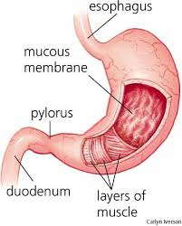
    - SMALL INTESTINE
- Intestinal digestion. After the pylorus open, the chime travels from the stomach into the small intestine (duodenum). Once in the duodenum, chime mixed with digestive secretions released by the small intestine (intestinal juice), as well as secretions from two other organs: the pancreas (pancreatic juice) and liver (bile).
- Pancreatic juice is a watery solution of sodium bicarbonate that neutralizes acidic chime. It contains digestive enzymes such as pancreatic amylase, which digests polysaccharides; pancreatic lipase, which digests fats; and peptidase, which digests proteins (peptides from stomach).
- Bile helps to digest fats by breaking them up.
- Intestinal juice is secreted by glands on the intestinal wall. It contains digestive enzymes that digest proteins (peptidases), sugars (disaccharidases), fats (lipases) and nucleic acids (nucleases).
When the chyme mixes with the bile, pancreatic and intestinal juices, it is transformed into chyle. Chyle is formed by various nutrients which have been prepared for absorption: water, mineral salts, amino acids, monosaccharides or simple sugars, fatty acids, glycerol and vitamins. It contains undigested substances such as dietary fibre. Those nutrients must be distributed to the tissues where cells will use them to obtain energy or make new molecules.
- Food absorption refers to the passage of nutrients to our blood. This allows those nutrients to be distributed across the whole organism. The inner layer of the small intestine is covered in creases, known as villi (3000/cm²). These villi are covered by a single layer of cells which, in order to increase the surface area, have extra creases in their plasmatic membrane called microvilli. This increases the total surface area to 400 m2. Underneath these cells there is a large network of microscopic blood capillaries surrounding a blind-ended lymph vessel. Nutrients pass through the epithelial cells into the capillaries or lymph vessels.
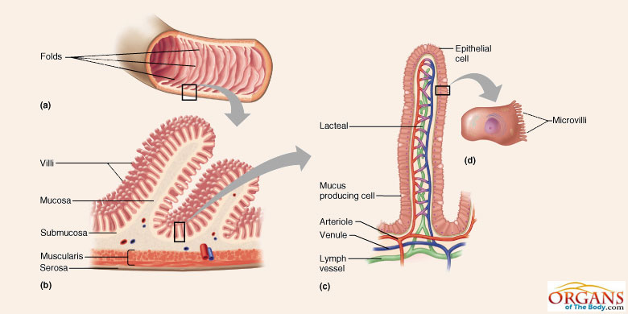
    - LARGE INTESTINE
Undigested substances that have not been absorbed move through the ileocecal valve into the large intestine. Water and some B vitamins and vitamin K produced by intestinal flora are reabsorbed in the large intestine.
Egestion: The substances fermented by the intestinal flora are compacted to form faeces and are temporarily stored. Faeces move through the descending colon and rectum by peristalsis, and are expelled to the outside through the anus by a mechanism called defecation. Faeces contain intestinal mucosa cells, bacteria and food waste.
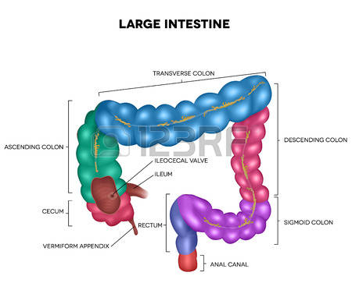
Activities
- Name the substances secreted by each one of the associated glands.
- In a diagram, sum up the parts of the digestive system and the organs each one has.
- Define bolus of food, chyme, chyle and egestion.
- List the digestive juices which act in the mouth, stomach and small intestine.
- Organise the following list in a table under two headings: mechanical digestion and chemical digestion: action of teeth, action of bile, peristaltic activity, action of saliva, action of the tongue.
- Copy and complete this table into your notebook.
Food | Digestive juice | Place | Nutrient
Complex sugar
Protein
Water
Fats
- Say which sentences are false and write them correctly in your notebook:
- In the stomach, the intestinal juices act on the proteins of the bolus of food.
- The walls of the small intestine move with peristaltic movements.
- Absorption takes place in the large intestine.
- The process of egestion begins in the small intestine.
- Explain the route a piece of meat would take trough the digestive tract and the transformations it would undergo.
- Briefly explain the role played by the intestinal villi in digestion.
- Look at the illustration of chemical digestion and sum up how complex sugars are transformed into simple sugars as they pass through the digestive tract.

Chemical digestion
 | COMPONENTS OF FOODS
DIGESTIVE PROCESS | COMPLEX SUGARS | LIPIDS (FATS) | PROTEINS | WATER AND MINERAL
Action of saliva in the mouth | They are cut into smaller fragments | They remain unaltered | They remain unaltered | They remain unaltered
Action of gastric juice in the stomach | The fragments remain unaltered | They remain unaltered | They are cut into smaller fragments | They remain unaltered
Action of bile, intestinal and pancreatic juices in the small intestine | The fragments are cut into simple sugars | They are cut into their components | The fragments are cut into amino acids (Aa) | They remain unaltered
Absorption in the intestinal villi | The simple sugars are absorbed | The components of the fats are absorbed | The amino acids are absorbed | The water and minerals are absorbed

- The human respiratory system.
The cells in our body, as well as nutrients, need oxygen (O₂) to obtain energy in cell respiration. This process consists of oxidation of nutrients (mainly glucose and fatty acids) and energy releasing. As a result of cell respiration, water (H₂O) and carbon dioxide (CO₂) are generated and CO₂ have to be eliminated from cells and expelled from the body.
The respiratory system exchanges oxygen and carbon dioxide between the air and the blood. Oxygen is taken from the air and the carbon dioxide produced by cells is expelled.
The respiratory system is formed by the respiratory tract and lungs.
- Respiratory tract: it is made up of tubes or airways that collect oxygen and prepare it for cell consumption. These are: the nasal cavities, pharynx, larynx, trachea, bronchi and bronchioles.
- Nasal cavities: its inside is covered in a mucous membrane called the pituitary membrane, which contains numerous capillaries. It heats, moistens and cleans the air. When the air enters, most of the dust and microorganisms it contains become trapped in this mucus, which is then swallowed or expelled from the body.
- Pharynx: This area is common to the respiratory and digestive system, and contains the tonsils (two small masses containing white blood cells) and the epiglottis (it close the entrance to the larynx so that food continues down the oesophagus and cannot enter the airways. The pharynx is connected to the ears via the Eustachian tube.
- Larynx: its walls are formed of cartilage that continually keeps it open. The larynx contains the vocal cords, folds of tissue which vibrate when we breathe out, producing the sound of our voice.
- Trachea: this tube of about 12 cm has open cartilage rings at the back which keep the trachea open at all times. The inside is covered by an epithelium of ciliated cells and mucus-producing cells. Cilia moves mucus, filled with foreign particles, towards the larynx, where it is redirected to the oesophagus and stomach.
- Bronchi: the trachea is divided into two bronchi which have the same anatomy as the trachea. Each one leads to a lung and branches into progressively smaller ducts named bronchioles. Bronchioles do not have cartilage rings. They end in tiny sacs, called pulmonary alveoli, which are the true protagonists of gas exchange. Each person has about 400 million alveoli.
- Lungs: these two organs are formed of spongy tissue. They are inside the chest cavity, protected by the ribs and surrounded by two membranes called pleurae. The lungs are divided into various lobes. The right lung is larger and has three lobes. The left lung is smaller, with just two lobes. This is because the position of the heart. After travelling through the respiratory tract, air filled with oxygen reaches the pulmonary alveoli, where gas exchange occurs. Pulmonary alveoli only have a layer of flat cells (endothelium) and are covered by a network of capillaries that facilitate gas exchange between air and blood.
Air in the alveoli needs to be renewed constantly for gas exchange to function effectively. This process is called pulmonary ventilation or breathing (true respiration occurs in our cells). The respiration process consists of two stages: ventilation (air moving in and out of the lungs) and gas exchange (oxygen in the air inside the lungs transfers to the blood, and carbon dioxide in the blood moves into the air in the lungs).
- Pulmonary ventilation: This process involves many muscles that surround the chest: intercostal muscles (between the ribs), the abdominal muscles and the diaphragm (it separates the chest cavity from the abdominal cavity). Ventilation has two stages: the entrance of air or inspiration, and the release of air after gas exchange has occurred or expiration.
- Gas exchange: it takes place between the very thin walls of the blood capillaries and the pulmonary alveoli. The gases move from the area of highest concentration to the area of lowest concentration in a process called simple diffusion. The carbon dioxide in the blood therefore moves into the alveoli and is expelled from the body by exhalation. Oxygen in the air moves from the alveoli into the blood.

Activities
- Match each part of the respiratory system with its function. Write complete sentences in your notebook.
Parts | Functions
- Nose | - Spongy organs which contain the bronchial tree.
- Pharynx | - Gas exchange takes place here
- Larynx | - Composed of two cartilaginous tubes which enter the lungs
- Trachea | - Cavities located above the mouth which warm, humidify and clean the air as it enters the body
- Bronchial tree | - Common tube shared with the digestive system
- Alveoli | - It contains the epiglottis
- Lungs | - It connects the larynx with the lungs

- Explain the function of mucus in the respiratory system.
- Describe the tree-like structure in the respiratory system. Make a drawing to illustrate it.
- Which muscles are involved in the process of ventilation? Briefly explain the role of each one.
- Why is the trachea reinforced with cartilage rings?
- What special characteristics do alveoli have in order to facilitate the passage of respiratory gases through them?
- Completer the following sentences:
- Air enters the lungs during …………………… and air is pushed out of the lungs during ……………………..
- Blood that reaches the lungs after travelling around the body contains a high concentration of ………….
- The respiration process consists of two stages: …………………….. and ………………………………
- Blood that leaves the lungs after the gas exchange contains a high concentration of …………………….
- Air obtained from the trachea is 16% oxygen and 4.6% carbon dioxide. At another point, it contains 20.5% oxygen and 0.4% carbon dioxide. Which composition represents air being inhaled? And which represents air being exhaled? Justify your answer.
- What are the pleura?
- Why does air reach our lungs clean, humid and warm?

